

**Asset Practice Questions: Mathematics**

1. Bunjee starts from 2 and moves forward along the line. In each move, he jumps 5 steps forward.

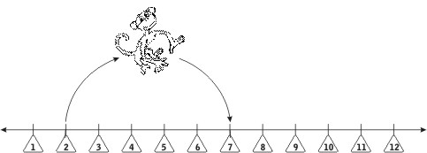

On which number will he be just after the first 3 moves?

A. 5

B. 15

C. 17

D. 32

2. In which of these numbers is the place value of 7 the greatest?

A. 7

B. 37

C. 171

D. 907

3. 3 Tens + 5 Hundreds + 2 Ones is

A. 352

B. 523

C. 253

D. 532

4. 32 circles are arranged in 4 rows in the figure below.

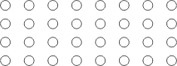

Which of these will give the number of circles IN A ROW?

A. 32 ÷ 4

B. 4 x 8

C. 24 + 8

D. 4 - 1

5. Jumping Jack starts jumping from 0 and covers the same distance with every jump.

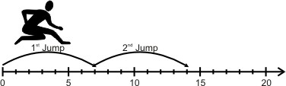

In which jump will he cross 30?

A. 4 th

B. 5 th

C. 10 th

D. 30 th

6. I have some flowers which are in 6 equal bunches as shown:

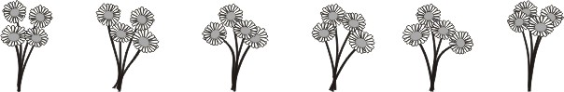

I want to put these flowers in exactly 8 equal bunches. How many flowers should I put in each bunch?

A. 3

B. 4

C. 6

D. 10

7. Which product will have the unit's digit as 8?

A. 82 x 49

B. 4 x 200

C. 48 x 28

D. 76 x 52

8. 7 × 37 = 37 + 37 + 37 + 37 + 37 + 37 + 37

What should be added to 7 × 37 to get 9 × 37?

(Note: You need not calculate the answers of 7 × 37 and 9 × 37.)

A. 2

B. 7 × 9

C. 2 × 37

D. 7 × 37

9. Which of the following gives the largest quotient?

A. 478 ÷ 5

B. 478 ÷ 9

C. 478 ÷ 7

D. 478 ÷ 12

10. Which of these number sentences is TRUE?

A. 493 ÷1 = 1

B. 493 ÷ 493 = 0

C. 493 ÷ 493 = 1

D. 493 ÷ 493 = 493

11. 2 + 2 + 2 + 2 + 2 + 2 = 4 ×

A. 6

B. 4

C. 3

D. 2

12. Which of these is 841 CLOSEST to?

A. 84 ones

B. 84 tens

C. 48 tens

D. 8 hundreds